Tankersley and Thorncliffe Wood - Saturday 24th August 2019

To make it easy for everyone, this walk starts at the same place as the May walk - Wentworth Office Park - S75 3DP.
From there we head Southish, dipping into High Green then East, under the motorway for a while before returning through Lower Pilley; a total of just under 6 miles. There are no long climbs or descents on this walk - but there are some short, steep slopes. Mainly firm underfoot (unlike last month), and there are a few shortcuts.
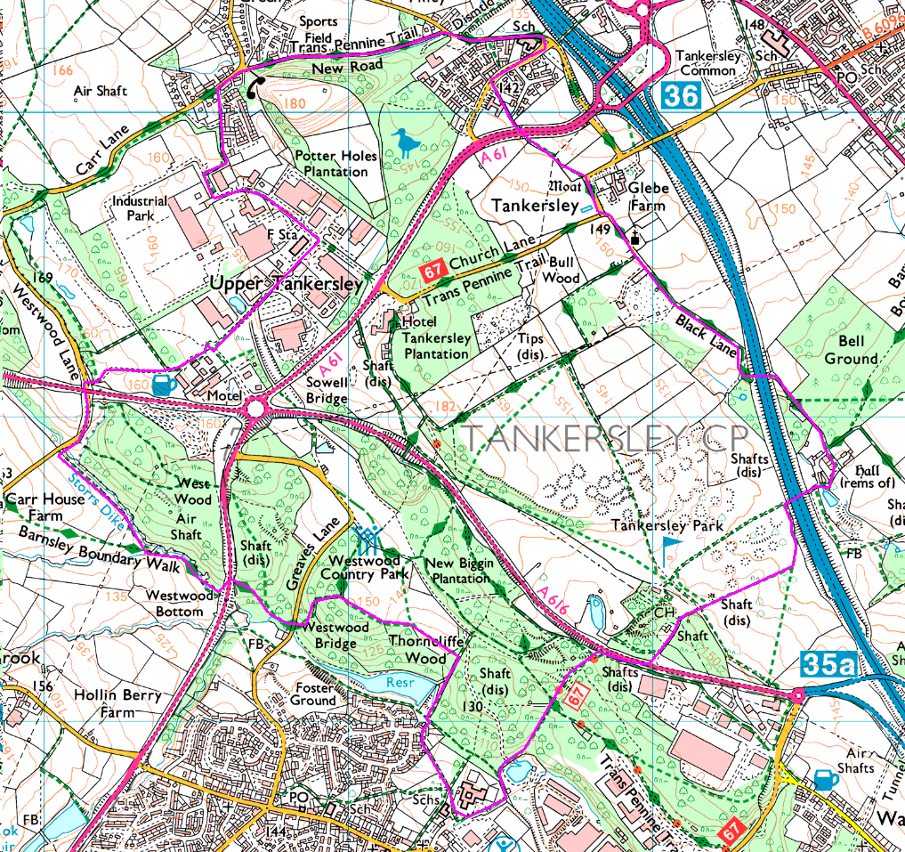
Meeting Instructions

Tankersley
Wentworth Office Park - Sheffield Mutual Friendly Society – S75 3DP
Road-side parking

Travelling by car from Sheffield and the South – via the motorway- Go to M1 junction 35A

At the roundabout at the top of the slip road follow the signs for A616 to Manchester (and M1 north!)

At a second roundabout take the third exist (the first goes back to Sheffield via high Green) the second is the A616 to Manchester and the third goes onto Wentworth Industrial estate.

**As you enter the estate MacDonalds and then a petrol station on your right, and a Premier Inn hotel to your left.

Go to the end of this road and turn left. It is the dead end access to Sheffield Mutual Building Society Offices and Man Softwear.

On Saturdays there should be plenty of road-side parking

Travelling by car from Sheffield – non-motorway route.
Travel out of Sheffield past Hillsborough stadium and up Penistone Road.
Continue on the A61 out of Sheffield and right out past High Green.

Beyond High Green you’ll reach a major roundabout. The first exit is the A616 to Manchester and the 3rd and 4th exits are to the motoway. You need the second exit onto Wentworth Industrial Estate. Head for MacDonalds!

Now follow the instructions from **

